How to find the gradient of a line?
On the coordinate plane, the slant of a line is called the slope / gradient. Gradient is the ratio of the change in the y-value over the change in the x-value, also called rise over run.
Given any two points on a line, you can calculate the gradient of the line by using this formula: $\frac{y_{2-y_{1}}}{x_{2-x_{1}}}$
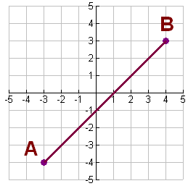
For example: Given two points, A= (-3 ; –4) and Q = (4 ; 3), on the line we can calculate the gradient of the line.

Solution: Gradient $= \frac{3-(-4)}{4-(-3)}=\frac{3+4}{4+3}=1$
What is a Negative Gradient?
Let's look at a line that has a negative gradient.
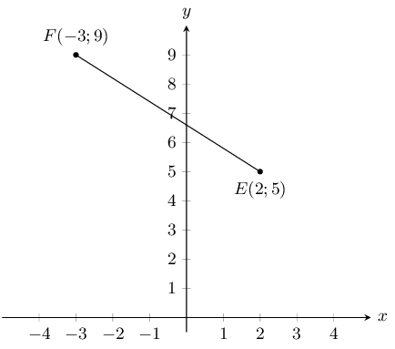

For example: Consider the two points, F(-3 ; 9) and E(2, 5) on the line. What would be the gradient of the line?

Solution: Gradient = $\frac{5-9}{2-(-3)}=\frac{-4}{5}$
Exercise 2
Calculate the gradients of the straight lines joining the following points:
- A(1;2) and B(4;2)
- C(-1;2) and D(4;-2)

